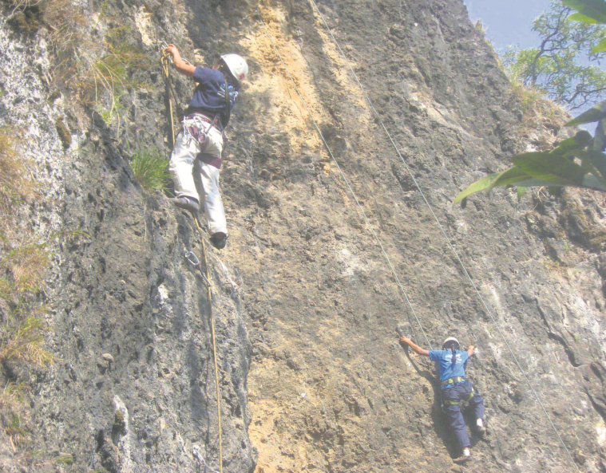**Rock Climbing**

Rock climbing is another adventure sport activity available in Pokhara. The Three Sisters Adventure at Methalang, Sarangkot operates it. A total of 14 people can simultaneously ascend to the top of the two boulders standing 10 meters, and 21 meters each. Despite the danger involved, a thrilling experience is guaranteed while climbing the steep boulders. Nevertheless, you can also go for natural rock climbing site in Pokhara. Another artificial rock climbing venue is situated at the International Mountain Museum. This artificial structure is 22 meters high.

Link: <https://myrepublica.nagariknetwork.com/mycity/news/five-adventure-sports-to-do-in-pokhara-this-festive-season>

Link: <https://www.explore-share.com/trip/rock-climbing-pokhara-everest-nepal/>

**Rock climbing areas in Nepal:**

* Nagarjun Forest – 20-minute drive from Kathmandu
* Hattiban – 1-hour drive from Kathmandu
* Bimal Nagar – 20-minute drive from Bandipur
* Nagarkot – This bolted climbing area is hard to find without a guide.
* Namche Bazaar – Bouldering field is 30-minute walk; ask local how to get there

**Most of the spots** are situated to the north and northwest of the valley, in the vicinity of the Nagarjun forest and the shivapuri watershed and wildlife reserve, Pasang Lembu Sherpa wall, Astra Wall. Your rock climbing trip can therefore be combined with bird watching, game watching and experiencing some of the last of the valley's wilds. Nagajuna is a verdant hill located to the northwest of the Swyambhu Stupa and believed to be the place where the famous Buddhist philosopher. Nagarjun meditated. The cliff here is located inside the Nagajun forest reserve suitable for both beginners and wall rats. The limestone rock face is about 12-15 m high and bears the remnants of earlier climbs, what purist would describe as "piton scarred” or a defaced face.